# Design & Innovation

**Project Title**-**Fighter Drone**

**hackathon**

\

**Submitted by:- rahul dev singh**

**Email id:- rahuldevs025@gmail.com**

**What Is A Drone ?**

#### Drone Types And Sizes

UAV drones come in a wide variety of sizes, with the largest being mostly used for military purposes such as the Predator Drone. The next in size are unmanned aircraft, which have fixed wings and require short runways.

These are generally used to cover large sections of land, working in areas such as geographical surveying or to combat wildlife poaching.

#### VTOL Drones

Next in size for drones are what is known as VTOL drones. These are generally quadcopters but not all. VTOL drones can take off, fly, hover and land vertically. The exact meaning of VTOL is “Vertical Take-Off and

Landing”.

A few of the latest small UAV drones such as the [DJI Mavic Air](https://youtu.be/GQ1XqzNFVog) and [DJI](https://youtu.be/nHCnY-1upk0) [Spark](https://youtu.be/nHCnY-1upk0) take VTOL to the next level and can be launched from the palm of your hand.

#### Radar Positioning & Return Home:-

The latest drones have dual Global Navigational Satellite Systems (GNSS) such as GPS and GLONASS.

Drones can fly in both GNSS and non satellite modes. For example, DJI drones can fly in P-Mode (GPS & GLONASS) or ATTI mode, which doesn’t use GPS.Highly accurate drone navigation is very important when flying, especially in drone applications such as creating 3D maps, surveying landscape and SAR (Search & Rescue) missions.When the quadcopter is

first switched on, it searches and detects GNSS satellites. High end GNSS systems use Satellite Constellation technology. Basically, a satellite constellation is a group of satellites working together giving coordinated coverage and are synchronized, so that they overlap well in coverage. Pass or coverage is the period in which a satellite is visible above the local horizon.

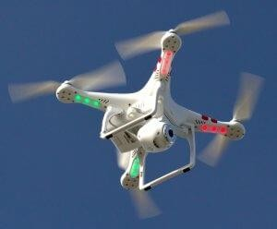

### Drone Sensors Senses:-

* Vision Sensor.
* Ultrasonic.
* Infrared.
* Lidar.
* Time of Flight.
* Monocular Vision

No fly zone Drone

Technologies Used:-

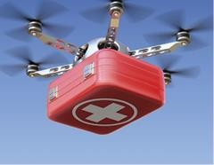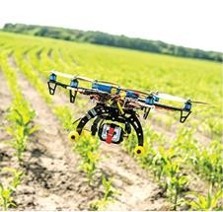

The motors and propellers are the **drone technology**, which move

the **UAV** into the air and to fly in any direction or hover. On a **quadcopter**, the motors and propellers work in pairs with 2 motors / propellers rotating clockwise (CW Propellers) and 2 motors rotating Counter Clockwise (CCW Propellers).

### Popular Uses Of Drone:-

**1.**

1. [**Exploring the true potential of Earth Observation**](https://www.geospatialworld.net/article/making-the-eo-magic-work/)

### Security Purpose.

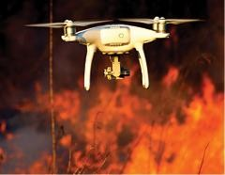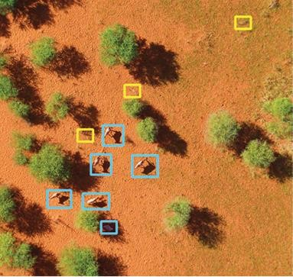

1. Attack Drone:-

Basic language and technology used:- 1.python language

2.Using of IOT and combination of Machine Learning and Advance Equipments.

Advantages:-

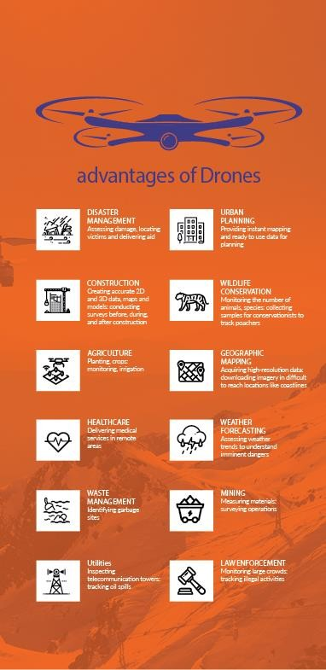

## Why we need?

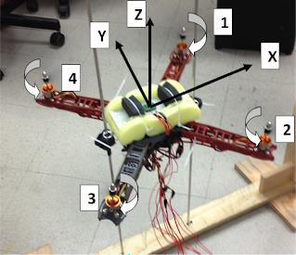

The single main reason that they are popular for small **drones** is mechanical simplicity. It's worth pointing out that a **quadcopter** is LESS stable than an equivalent regular helicopter (and I'll explain why in a sec), and is also LESS efficient than an equivalent regular helicopter.

Our project:-

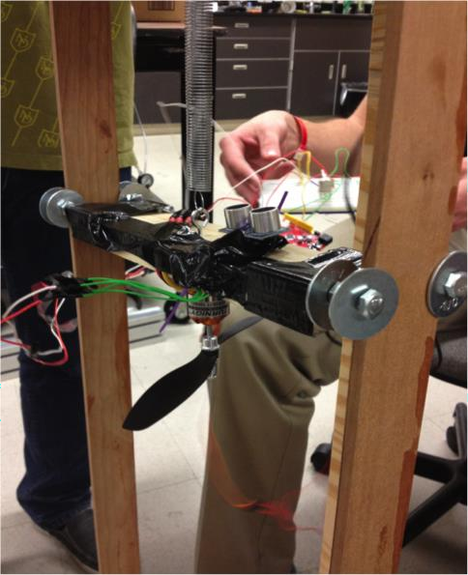

# DESIGN:-

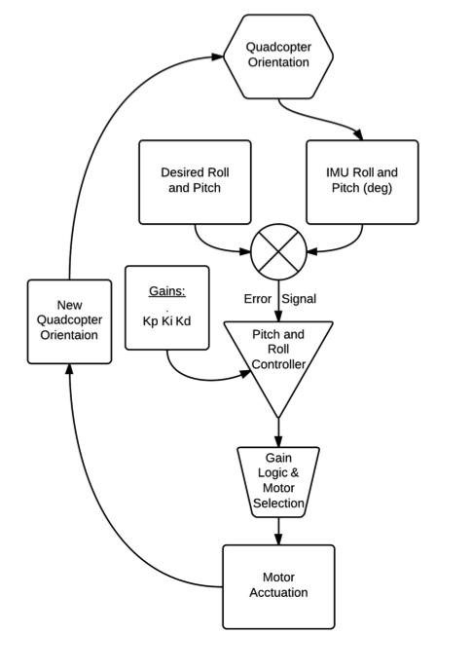

The quadcopter design was based off models found online. Many of these models list the parts used. Based on these listed parts, motor, propeller, and battery selections were made.

1. Propeller
2. Motor
3. Battery
4. Frame
5. Seeeduino
6. IMU

Flow Diagram:-

Conclusion:-

These are the basic themes of our work, and project is under process this is our design prototype documentation.